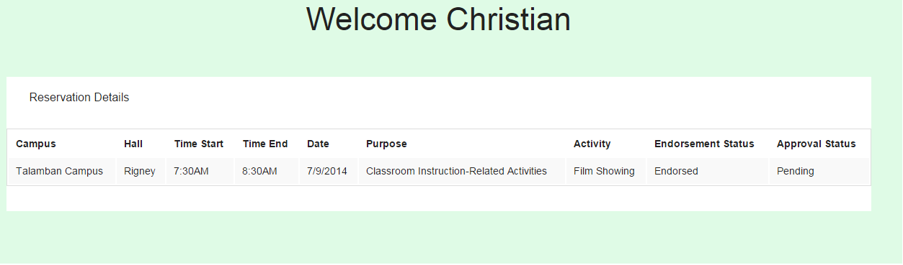

1. Campus Column

* Description: This is where the user views the campus that he/she reserved.
  + Action: User views the campus detail of each of his/her reservation.

1. Hall Column

* Description: This is where the user views the hall that he/she reserved.
  + Action: User views the hall detail of each of his/her reservation.

1. Time Start Column

* Description: This is where the user views the Time Start that he/she reserved.
  + Action: User views the Time Start detail of each of his/her reservation.

1. Time End Column

* Description: This is where the user views the Time End that he/she reserved.
  + Action: User views the Time End detail of each of his/her reservation.

1. Date Column

* Description: This is where the user views the Date that he/she reserved.
  + Action: User views the Date detail of each of his/her reservation.

1. Purpose Column

* Description: This is where the user views the Purpose that he/she reserved.
  + Action: User views the Purpose detail of each of his/her reservation.

1. Activity Column

* Description: This is where the user views the Activity that he/she reserved.
  + Action: User views the Activity detail of each of his/her reservation.

1. Endorsement Status Column

* Description: This is where the user views the Endorsement Status that he/she reserved.
  + Action: User views the Endorsement Status of each of his/her reservation.

1. Approval Status Column

* Description: This is where the user views the Approval Status that he/she reserved.
  + Action: User views the Approval Status of each of his/her reservation.